

PROPOSAL DOCUMENT

Vulnerability Assessment &
Penetration Testing (VAPT) Report

Future Media

25th July 2025
© Sautech (Pty) Ltd. http://www.sautech.net

TABLE OF CONTENTS

1 Executive summary 3
2 scope of testing 3
3 Methodologies used 3
3.1 Nmap / Zenmap 3
3.2 Greenbone Enterprise 3
Stay One Step Ahead of Attackers 4
3.3 OWASP 4
4 SCOPE OF SERVERS 5
4.1 160.242.46.84 5
4.2 160.242.76.233 6
5 Reporting Conclusion 7
6 Auditors 7

Executive summary
The objective of this assessment was to identify security vulnerabilities, business logic flaws, and missing best security practices. The tests were conducted from the perspective of an attacker or malicious user, without causing any disruption to the functionality or performance of the application or network. Additionally, a comprehensive scan of the infrastructure was performed to simulate a real-world attack scenario, such as an internal network breach or exposure on a shared public subnet.
The assessment, including scans and testing, was carried out over seven (7) business days to ensure a thorough and methodical audit. These scans also examined unidentified connectivity options, such as packet SYN requests.

The overall results will be published below.
Recommendations are offered and mentioned throughout this document.

scope of testing

Security assessments include testing for security loopholes in the scope defined below. Apart from the following, no other information was provided. Nothing was assumed at the start of the security assessment. The following scope of servers were covered under the security audit:

- 160.242.46.84
- 160.242.76.233

Methodologies used

Sautech performed various audit techniques that includes the following:

Nmap / Zenmap

Nmap, short for Network Mapper, is a free and open source tool used for vulnerability checking, port scanning and, of course, network mapping. Despite being created back in 1997, Nmap remains the gold standard against which all other similar tools either commercial or open source, are judged.

To deploy Nmap, users originally had to have some advanced programming skills, with the introduction of the Zenmap tool for Nmap, which adds a graphical interface that makes launching the program and analysing the returned output it generates much more accessible.

Greenbone Enterprise
Greenbone is the world’s most widely used vulnerability management provider.

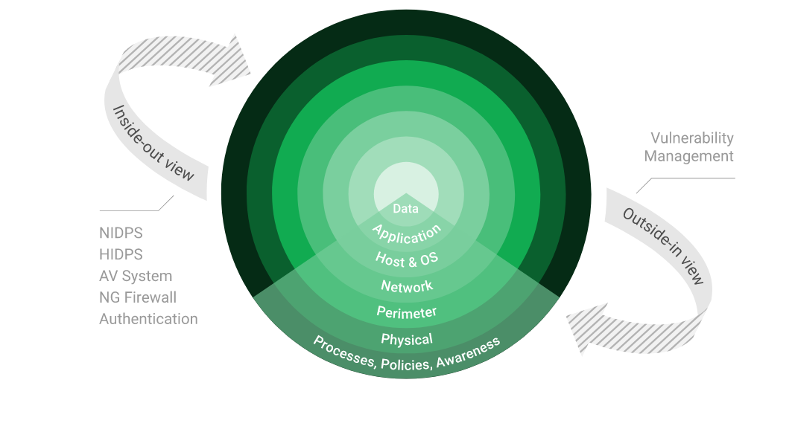

Stay One Step Ahead of Attackers
IT security is a process – Open Source vulnerability management provides the foundation. Once you know where the chinks are in your armor, you can do something about them.

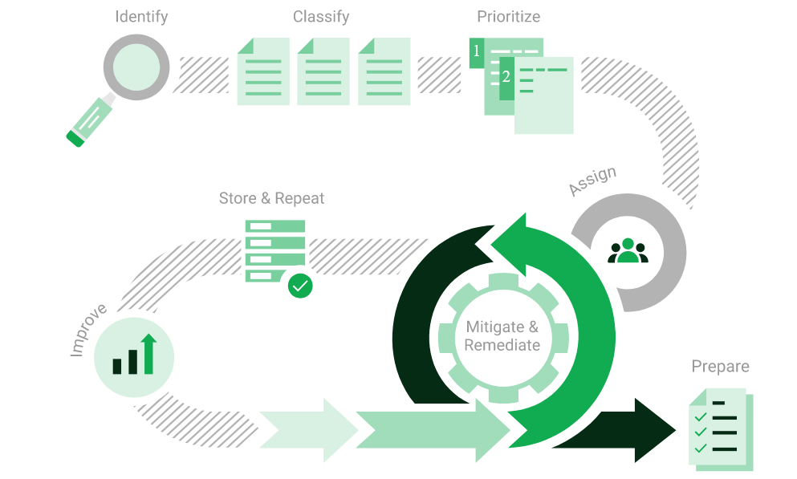

The process – from recognition to remedy and monitoring – represents a continuous cycle. You’ll always be one step ahead of attackers.

OWASP

The Open Web Application Security Project (OWASP) is an online community that produces freely-available articles, methodologies, documentation, tools, and technologies in the field of web application security. The Open Web Application Security Project (OWASP) provides free and open resources. It is led by a non-profit called The OWASP Foundation. The OWASP Top 10 - 2021 is the published result of recent research based on comprehensive data compiled from over 40 partner organizations.

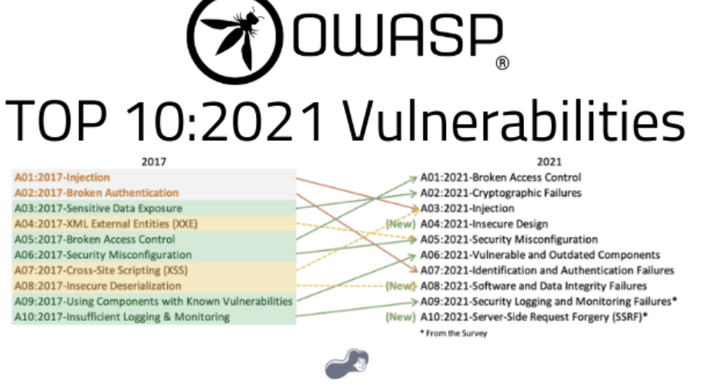

SCOPE OF SERVERS

160.242.46.84

We have performed the following types of scans / attacks on the production server namely:

- Greenbone Enterprise - The Greenbone Report will be provided as a separate attachment.
- OWASP - The OWASP Report will be provided as a separate attachment.
- Port Mapping – Nmap / Zenmap (Open / Exposed Services) These were performed from unknown and known locations to test not just the security from the perimeter, but also include local network. Based on the port mapping open access to Public and Private, selected coordinated assessments were performed specific to the open connectivity received.

Port Mapping – Nmap / Zenmap
Nmap can be used by hackers to gain access to uncontrolled ports on a system. All a hacker would need to do to successfully get into a targeted system would be to run Nmap on that system, look for vulnerabilities, and figure out how to exploit them.

The below screenshot demonstrates the open network port mapping:

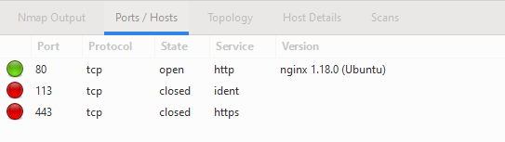

Remote Operating System Detection:

- Used Port: 80/tsp (open)
- Used Port: 113/tsp (closed)
- Used Port: 443/tsp (closed)

160.242.76.233

We have performed the following types of scans / attacks on the production server namely:

- Greenbone Enterprise - The Greenbone Report will be provided as a separate attachment.
- Port Mapping – Nmap / Zenmap (Open / Exposed Services) These were performed from unknown and known locations to test not just the security from the perimeter, but also include local network. Based on the port mapping open access to Public and Private, selected coordinated assessments were performed specific to the open connectivity received.

Port Mapping – Nmap / Zenmap
Nmap can be used by hackers to gain access to uncontrolled ports on a system. All a hacker would need to do to successfully get into a targeted system would be to run Nmap on that system, look for vulnerabilities, and figure out how to exploit them.

The below screenshot demonstrates the open network port mapping:

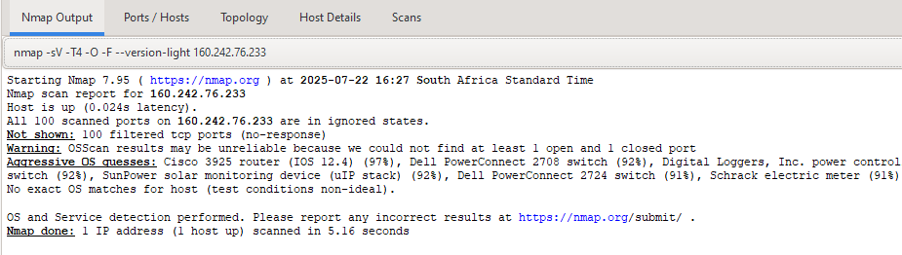

Remote Operating System Detection:

- Used Port: All ports closed.

Reporting Conclusion
The OWASP scan reports are provided separately from this main document for ease of reference. These detailed reports should be shared with the relevant contractors and support teams to guide the necessary updates and remediation actions.
The testing methodologies applied include Greenbone and OWASP standards. Our scans confirmed that the firewall is effectively blocking all known ports, which is a strong indication of sound perimeter security. To validate this further, we conducted scans from multiple IP addresses across different geographic regions, taking into account your use of geo-location-based firewall restrictions. All scans yielded consistent results, which is a positive outcome.
Additionally, we received alerts from Future Media indicating that intrusion attempts were detected during our tests. This confirms that your monitoring systems are functioning as intended and provide effective threat detection.
The inbound access configurations on the scanned IPs appear to be professionally implemented, and we are satisfied with the level of security in place.
Overall, we are very pleased with the security posture and configuration of your environment. Your team has done an excellent job in setting up and maintaining these systems.
Three (3) addendum reports are attached to this report and should be read as one document.

- 160.242.46.84 – GREENBONE
- 160.242.46.84 – OWASP
- 160.242.76.233 – GREENBONE

With the following test performed:

- Network scanning
- Knows network attacks
- External HTTP and Port exploits
- Vulnerability assessment on CVE

Auditors

These audits were concluded over a period of seven (7) business days.
We hereby confirm that the above information is true and correct:

25th July 2025 – Krugersdorp, South Africa

_________________________ _________________________
Riaan van Jaarsveld Lukas Janse van Rensburg
Security Expert – CCSA / Certified Pen Tester Security Engineer

